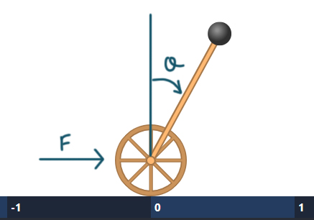

|  |  |  |
| --- | --- | --- |
|  |  | 1 |

|  |  |  |
| --- | --- | --- |
|  |  |  |
|  |  |  |

And linearized system;

$$x_{1}=x, x_{2}=\dot{x}, x_{3}=θ, x_{4}=\dot{θ}$$

$$cosθ≅1, sinθ≅θ, {\dot{θ}}^{2}≅0$$

$$\frac{F-μ\left(M+m\right)gx_{2}-mgx_{3}}{\left(2M\right)}=\ddot{x}$$

$$\ddot{θ}=\frac{gx_{3}}{l}-\frac{F-μ\left(M+m\right)gx_{2}-mgx_{3}}{\left(2Ml\right)}$$

$$\ddot{θ}=-\frac{F}{2Ml}+\frac{μ\left(M+m\right)g}{2Ml}x_{2}+\frac{2Mg+mg}{2Ml}x_{3}$$

Linear system In state space form

$$\left[\begin{matrix}\dot{x} \\ \ddot{x} \\ \dot{θ} \\ \ddot{θ}\end{matrix}\right]=\left[\begin{matrix}0 & 1 & 0 & 0 \\ 0 & -\frac{μ\left(M+M\right)g}{2M} & -\frac{mg}{2M} & 0 \\ 0 & 0 & 0 & 1 \\ 0 & \frac{μ\left(M+m\right)g}{2Ml} & \frac{2Mg+mg}{2Ml} & 0\end{matrix}\right]\left[\begin{matrix}x \\ \dot{x} \\ θ \\ \dot{θ}\end{matrix}\right]+\left[\begin{matrix}0 \\ \frac{1}{2M} \\ 0 \\ \frac{-1}{2Ml}\end{matrix}\right]\left[F\right]$$